**TASK-1(HTML AND CSS) ASSESSMENT**

***HTML SOURCE CODE PART 1***

**1.**

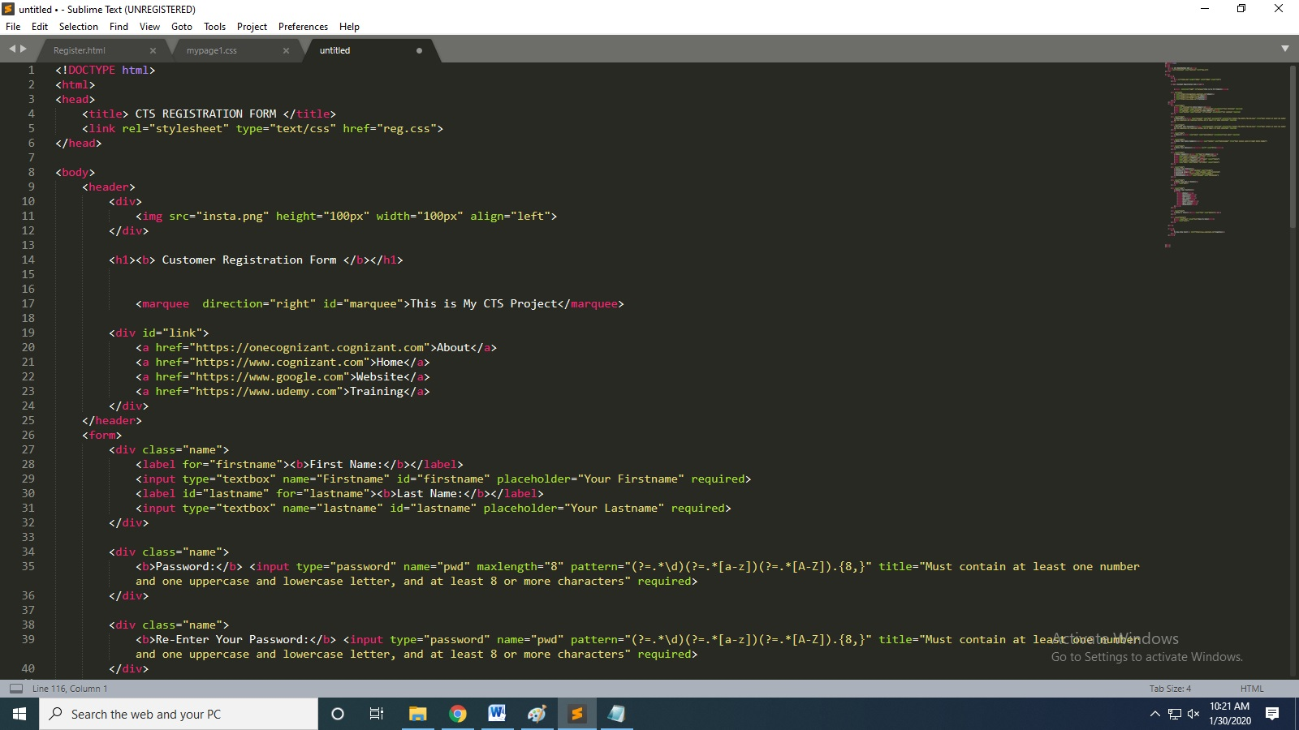

***HTML SOURCE CODE PART 2***

**2.**

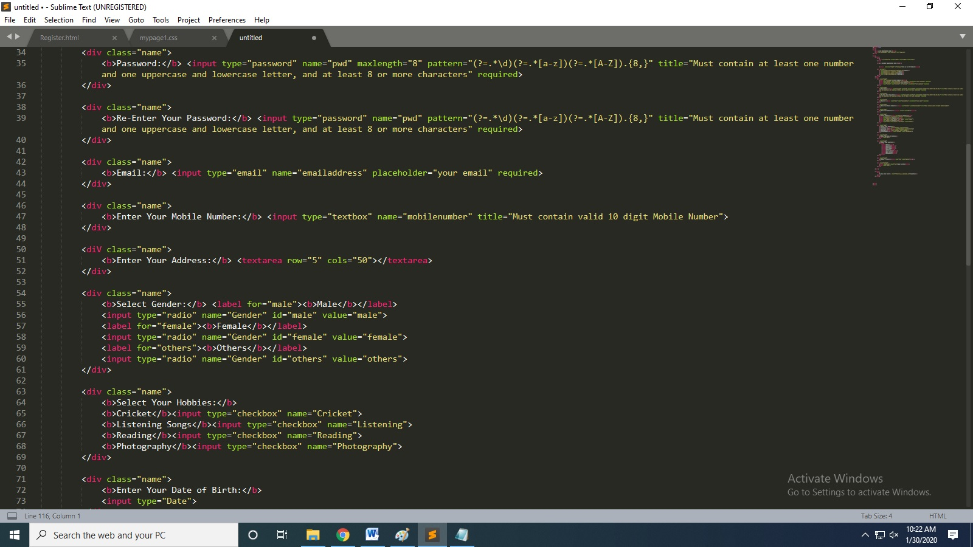

**LINKS USED:**

<HTTPS://WWW.COGNIZANT.COM>

<HTTPS://WWW.UDEMY.COM>

<HTTPS://ONECOGNIZANT.COGNIZANT.COM>

<HTTPS://WWW.GOOGLE.COM>

***HTML SOURCE CODE PART 3***

**3.**

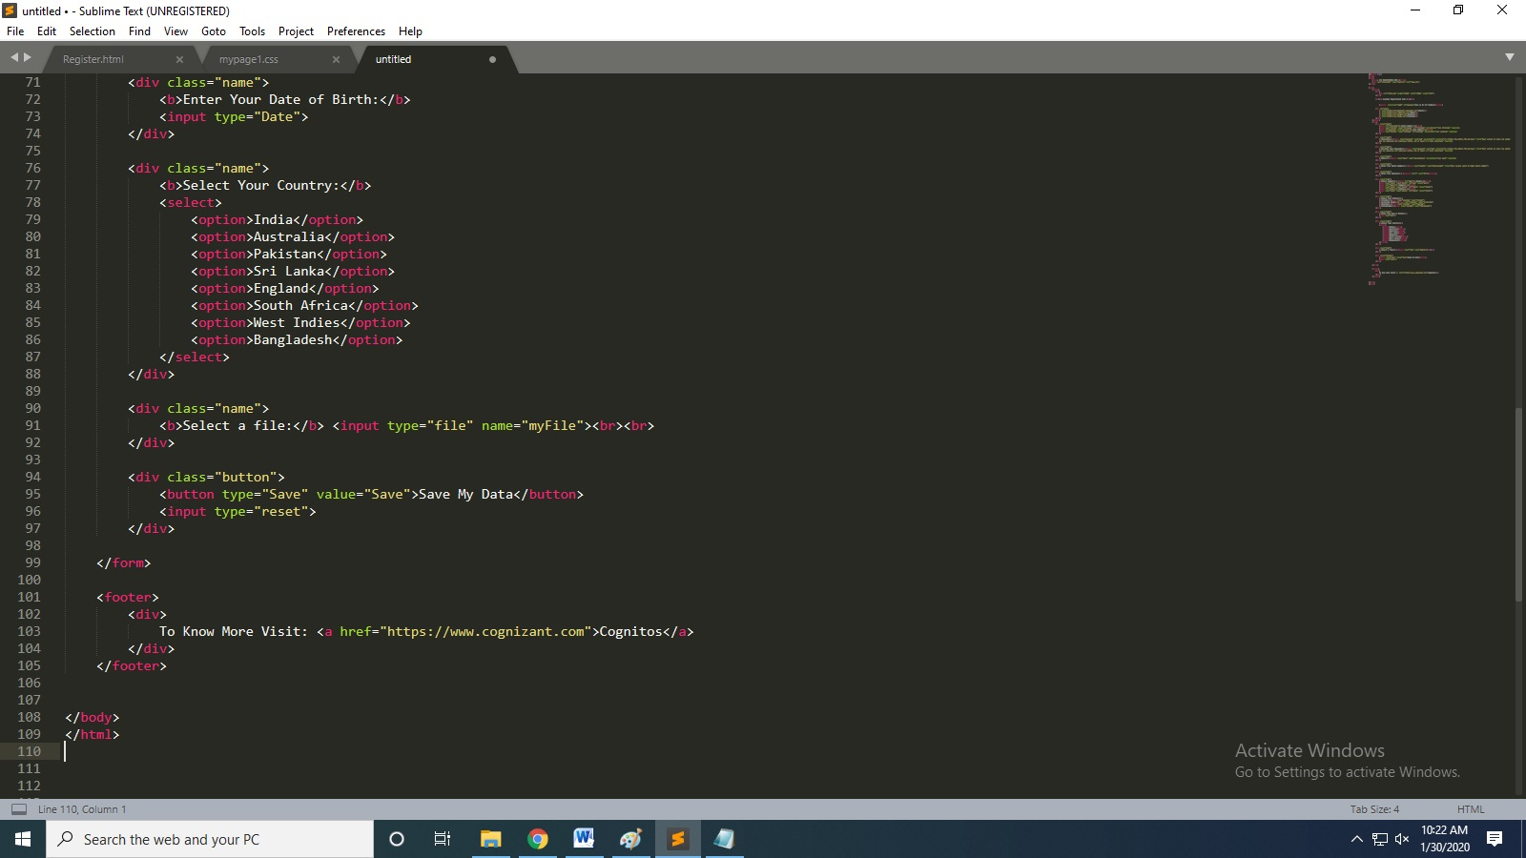

***CSS SOURCE CODE PART 1***

**1.**

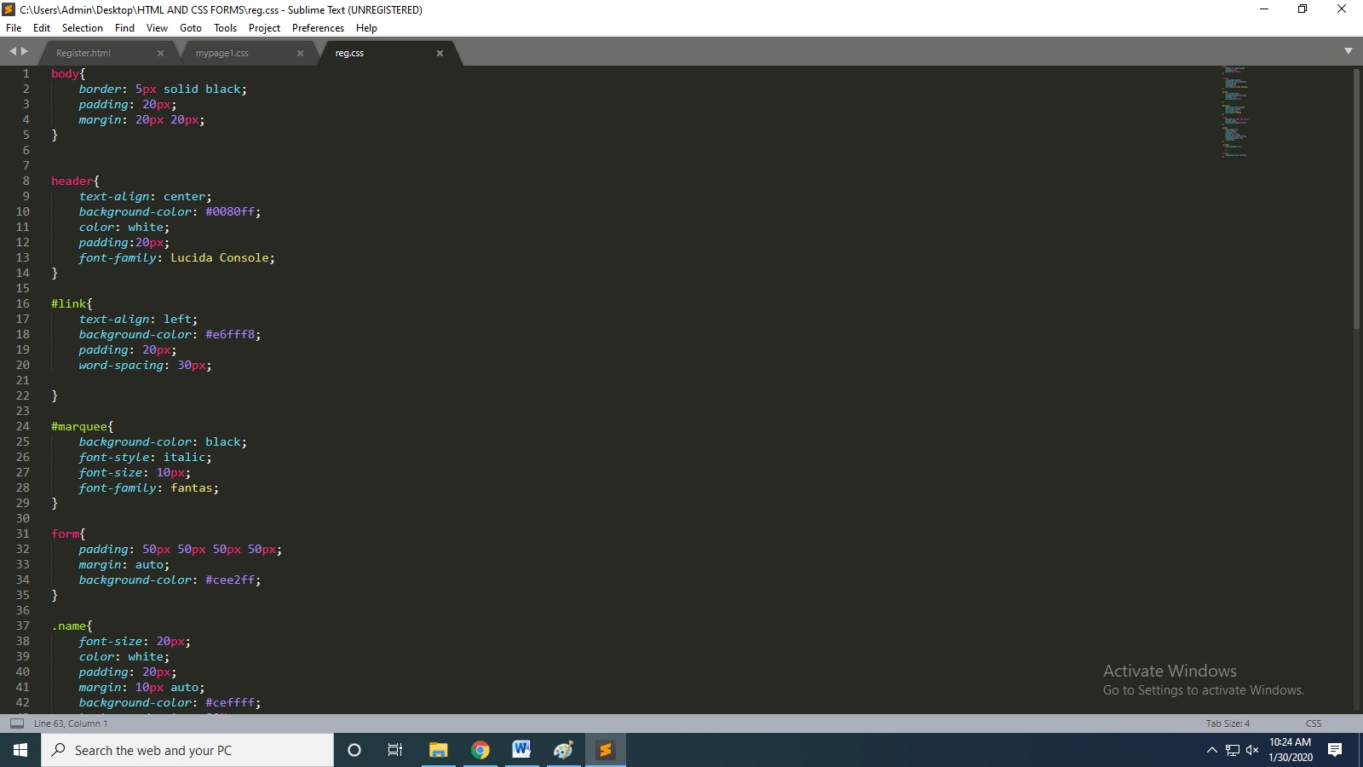

***CSS SOURCE CODE PART 2***

**2.**

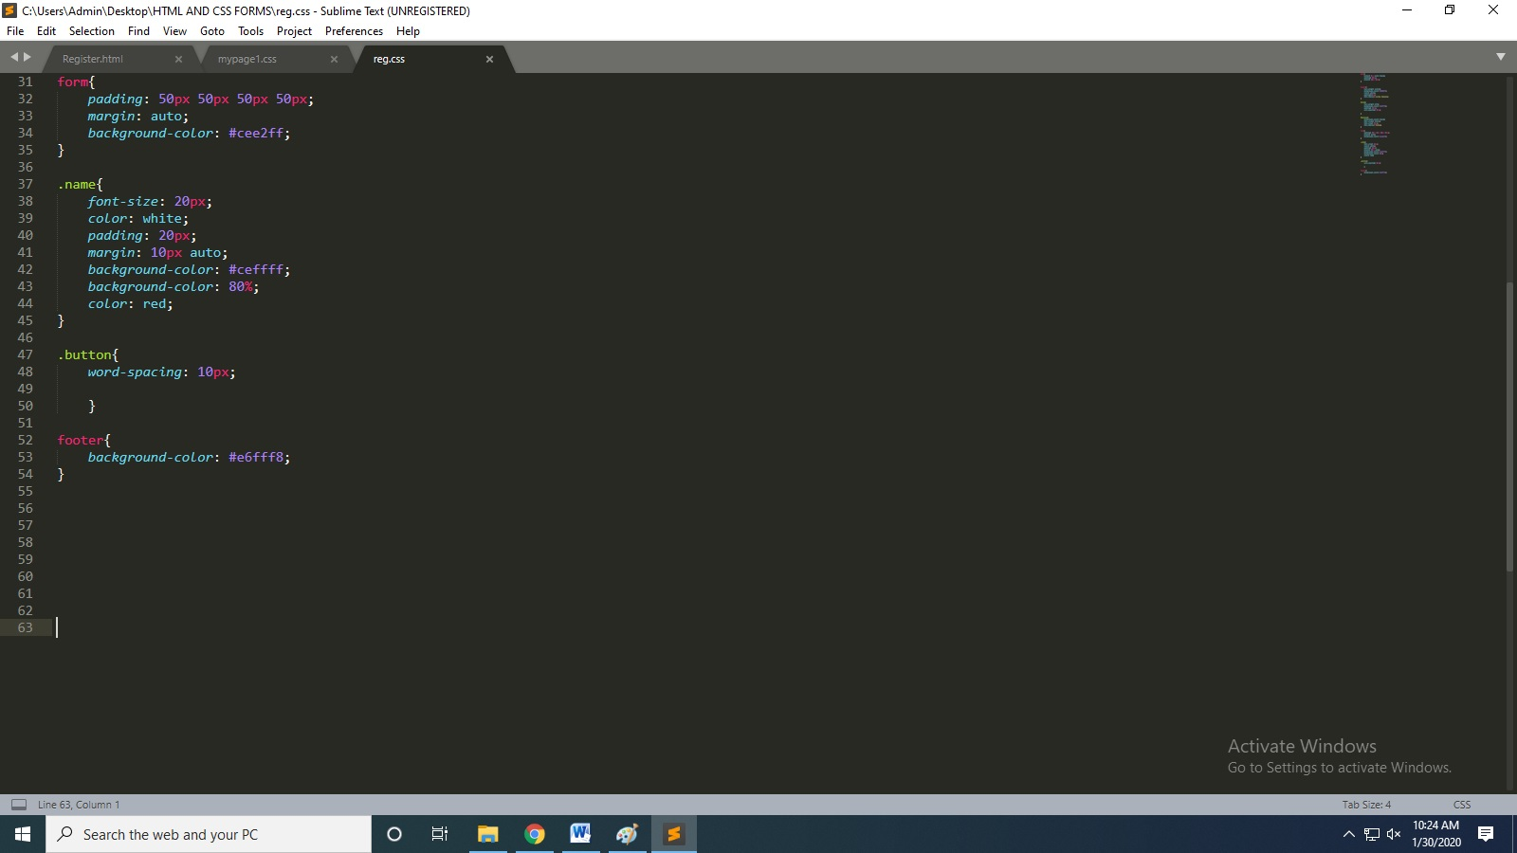

**IMAGE USED FOR LOGO:**



***OUTPUT SCREENS***

***PART 1***

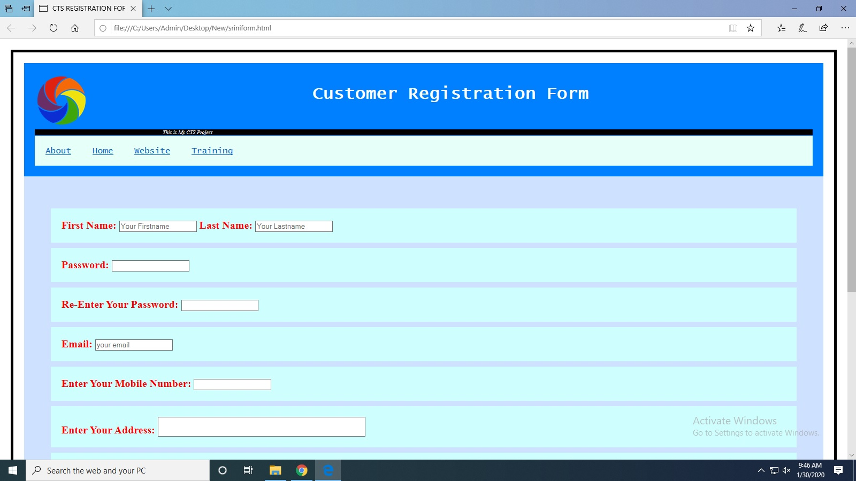

***PART 2***

